**Plant Disease Detection System for Sustainable Agriculture**

A Project Report

submitted in partial fulfillment of the requirements

of

AICTE Internship on AI: Transformative Learning

with

TechSaksham – A joint CSR initiative of Microsoft & SAP

by

**Aleeza Fatima O,**

**aleezafatima1021@gmail.com**

Under the Guidance of

**P.Raja**

**Master Trainer, Edunet Foundation.**

**ACKNOWLEDGEMENT**

I take this opportunity to present my votes of thanks to all those guideposts who really acted as lightning pillars to enlighten our way throughout this project that has led to the successful and satisfactory completion of this study.

I am really grateful to team TechSaksham and Edunet Foundation for providing us with an opportunity to undertake this project and providing us with all the facilities. I am highly thankful to Pavan Sumohana sir for his active support, valuable time and advice, whole-hearted guidance and sincere cooperation.

Lastly, I am thankful to Raja sir who have been instrumental in creating a proper, healthy and conducive environment and including new and fresh innovative ideas for us during the project, without their help, it would have been extremely difficult for us to prepare the project in a time-bound framework.

#### **I**

#### **ABSTRACT**

The Plant Disease Detection System for Sustainable Agriculture aims to assist in early diagnosis of plant diseases to promote healthier crops and reduce the use of harmful chemicals. Utilizing Python frameworks such as TensorFlow, Keras, Streamlit, and Jupyter Notebook, this project leverages deep learning techniques to automatically identify diseases in plants from images. The system trains on a large dataset of labeled images, using Convolutional Neural Networks (CNNs) for accurate classification. Streamlit is used for creating a user-friendly web application interface, enabling easy upload and instant detection results. The project’s primary goal is to enhance agricultural sustainability by providing farmers with an efficient and scalable solution to monitor plant health, thereby increasing crop yield and minimizing the environmental impact.

**II**

**TABLE OF CONTENT**

**Acknowledgement I**

**Abstract II**

**Table of Content III**

**List of Figures IV**

**Chapter 1.**  **Introduction 1**

1.1 Problem Statement 1

1.2 Motivation 1

1.3 Objectives 1

1.4 Scope of the Project 2

**Chapter 2.**  **Literature Survey 3**

2.1 Review of Relevant Literatures 3

2.2 Existing Models, Techniques and Methodologies 3

2.3 Gaps and Limitations in Existing Solutions 4

2.4 Addressing the Gaps 4

**Chapter 3.**  **Proposed Methodology 5**

3.1 System Design 5

3.2 Requirement Specification 6

**Chapter 4.**  **Implementation and Results 7**

4.1 Implementation 7

4.2 Result 9

4.3 GitHub Link for Code 9

**Chapter 5. Discussion and Conclusion 10**

5.1 Future Work 10

5.2 Conclusion 11

**References** 12

**III**

**LIST OF FIGURES**

|  |  |  |
| --- | --- | --- |
| **Figure No.** | **Figure Caption** | **Page No.** |
|  | Block Diagram for Project Implementation | 5 |
|  | Home Page | 7 |
|  | Disease Recognition Page | 8 |
|  | Browsing Files for Prediction | 8 |
|  | Disease Prediction | 9 |

**IV**

**CHAPTER 1**

**Introduction**

* 1. **Problem Statement:**

Agriculture is the backbone of many economies, providing food security and livelihoods to a significant portion of the global population. However, one of the major challenges faced by the agricultural sector is the prevalence of plant diseases, which can lead to substantial reductions in crop yield and quality. Traditional methods of plant disease detection rely heavily on manual inspection by experts or farmers. These methods are time-consuming, subjective, and often inaccessible to small-scale farmers due to the high cost of expert consultations. Additionally, the late detection of diseases often results in the excessive use of chemical pesticides, causing harm to the environment, human health, and biodiversity. There is a pressing need for a reliable, cost-effective, and scalable solution to address this issue.

**1.2 Motivation:**

The motivation for this project stems from the increasing global emphasis on sustainable agricultural practices. Early and accurate detection of plant diseases can significantly reduce crop losses and the indiscriminate use of pesticides, fostering environmentally friendly farming. Recent advancements in deep learning and image processing present a unique opportunity to automate plant disease detection. By leveraging these technologies, it is possible to create a system that is not only efficient but also accessible to farmers worldwide. The prospect of combining cutting-edge technology with real-world agricultural challenges drives the development of this project.

* 1. **Objective:**

The primary objectives of this project are as follows:

* To design and develop a deep learning-based system capable of detecting and classifying plant diseases from images with high accuracy.
* To create an easy-to-use web application interface for farmers and agricultural stakeholders to interact with the model.
* To minimize the environmental impact of agriculture by promoting the judicious use of pesticides through early disease detection.
* To contribute to the broader goal of sustainable agriculture by improving crop management practices and reducing losses due to diseases.

**1**

* 1. **Scope of the Project:**

This project focuses on developing a system that can detect and classify a range of plant diseases using image-based deep learning models. The scope includes:

* Training a Convolutional Neural Network (CNN) on a diverse dataset of plant disease images to ensure high classification accuracy.
* Integrating the trained model with a web application built using Streamlit, allowing users to upload images and receive instant disease predictions.
* Ensuring that the system is user-friendly, cost-effective, and scalable for deployment in various agricultural settings.

Exploring the potential for future enhancements, such as extending the model to include more crops and diseases, and integrating the system into mobile platforms for greater accessibility.

**2**

**CHAPTER 2**

**Literature Survey**

* 1. **Review of Relevant Literatures:**

Verma, Gaurav, Taluja, Charu, and Saxena, Abhishek Kumar. "Vision Based Detection and Classification of Disease on Rice Crops Using Convolutional Neural Network" (2019). The study by Verma, Taluja, and Saxena utilized a convolutional neural network (CNN) for the accurate detection and classification of diseases in rice crops [1]. By training the CNN on a large dataset of diseased and healthy rice leaves, the model achieved promising results in identifying and categorizing various diseases affecting rice plants.

Shah, Nikhil and Jain, Sarika. "Detection of Disease in Cotton Leaf using Artificial Neural Network" (2019). Shah and Jain conducted research on disease detection in cotton leaves using an artificial neural network (ANN) [2]. Their study aimed to develop an efficient system for identifying diseases in cotton crops based on leaf images. By training an ANN using features extracted from the images, the authors achieved satisfactory accuracy in disease detection.

Kumari, Ch. Usha. "Leaf Disease Detection: Feature Extraction with K-means clustering and Classification with ANN" (2019). Kumari proposed a two-step approach for leaf disease detection, involving feature extraction using K-means clustering and disease classification using an artificial neural network [3]. The study demonstrated the effectiveness of this method in accurately identifying leaf diseases, contributing to improved accuracy and efficiency in disease detection systems.

* 1. **Existing Models, Techniques and Methodologies:**

Several methodologies have been explored in this domain:

* **Feature-based Machine Learning:** Traditional machine learning approaches involve feature extraction techniques such as color analysis, texture analysis, and shape descriptors. These features are then classified using algorithms like SVM, k-Nearest Neighbors (kNN), and Decision Trees.
* **Deep Learning Models:** CNN architectures have been applied for plant disease classification. These models have shown high accuracy rates due to their ability to learn hierarchical features.

**3**

* **Hybrid Approaches:** Some researchers have combined machine learning and deep learning techniques to enhance detection accuracy. For example, hybrid models may use CNNs for feature extraction and traditional classifiers for final predictions.
  1. **Gaps and Limitations in Existing Solutions:**

Despite the advancements, existing solutions have notable limitations:

* **Dataset Limitations:** Many models rely on specific datasets which may not encompass the diversity of real-world agricultural conditions.
* **Overfitting Issues:** Some deep learning models are prone to overfitting, especially when trained on limited or homogeneous datasets.
* **Scalability Challenges:** Most existing solutions are not optimized for deployment in resource-constrained environments, limiting their usability for small-scale farmers.
* **User Accessibility:** Few models provide a user-friendly interface for farmers, requiring technical expertise for operation.
  1. **Addressing the Gaps:**

This project aims to address these limitations by:

* Utilizing data augmentation techniques to improve model generalization and reduce overfitting.
* Developing a scalable and efficient CNN model tailored for diverse agricultural conditions.
* Integrating the model with a Streamlit-based web application to enhance accessibility and usability for non-technical users.
* Exploring potential integrations with mobile platforms to reach a wider audience, including farmers in remote areas.

By overcoming these challenges, the proposed system aspires to be a practical and impactful solution for plant disease detection in real-world agricultural settings.

**4**

**CHAPTER 3**

**Proposed Methodology**

* 1. **System Design:**

The proposed system follows a modular architecture to ensure scalability and ease of use. Below is the block diagram of the solution:

* **Input Module:** Users upload images of plant leaves via the web application interface.
* **Preprocessing Module:** Uploaded images are resized, normalized, and augmented to ensure consistency and improve model robustness.
* **Deep Learning Model:** A Convolutional Neural Network (CNN) processes the images to detect and classify diseases.
* **Output Module:** The prediction is displayed to the user with additional information on the disease and recommended actions.
* **Web Interface:** Built using Streamlit, this module ensures an intuitive user experience.

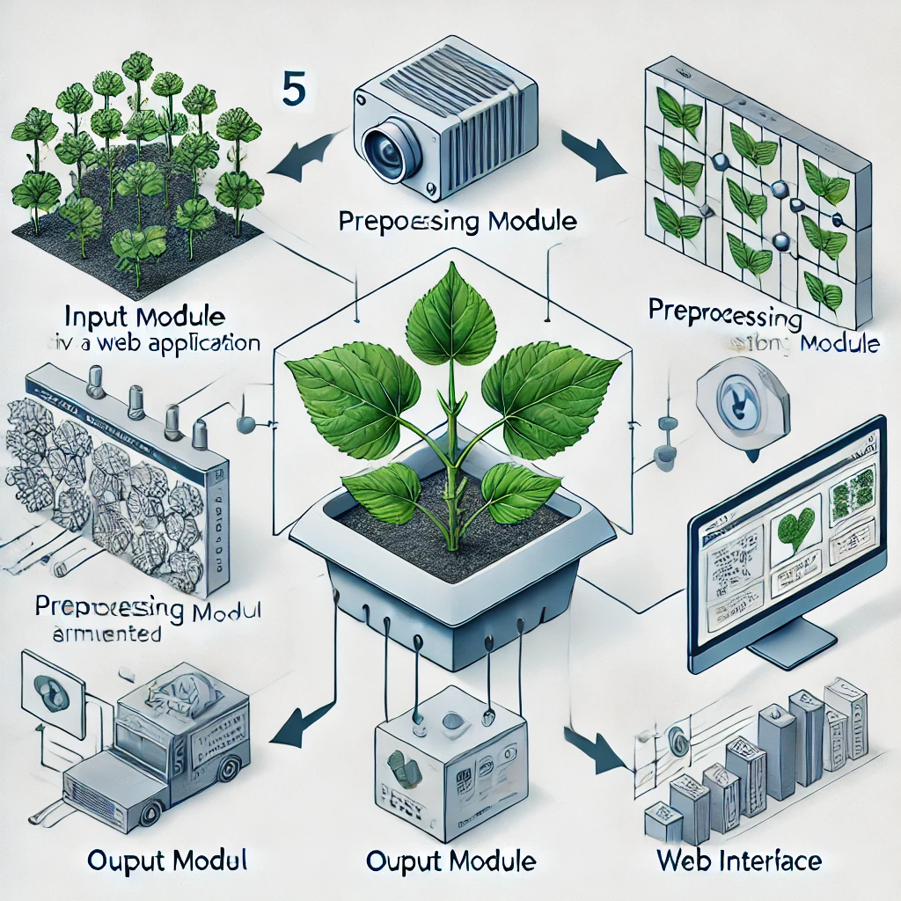

**Figure 1: Block Diagram for Project Implementation**

**5**

* 1. **Requirement Specification:**
     1. **Hardware Requirements:**
* Processor: Intel Core i5 or equivalent (minimum)
* RAM: 8 GB (minimum)
* Storage: 20 GB free disk space
* GPU: NVIDIA CUDA-enabled GPU (optional, for faster model training and inference)
  + 1. **Software Requirements:**
* Operating System: Windows 10, macOS, or Linux
* Python 3.8 or above
* Libraries and Frameworks:
  + TensorFlow
  + Keras
  + NumPy
  + Pandas
  + Matplotlib
  + Streamlit
* Development Tools: Jupyter Notebook, Anaconda

**6**

**CHAPTER 4**

**Implementation and Result**

* 1. **Implementation:**

The project implementation was carried out in the following phases:

**4.1.1 Model Loading:**

The model is pre-trained and loaded using TensorFlow's load_model function from the trained_plant_disease_model.keras file.

**4.1.2 Image Preprocessing:**

Uploaded images are resized to 128x128 pixels and normalized to be compatible with the model input format.

**4.1.3 Prediction:**

The model predicts the disease class by identifying the index of the maximum value in the output vector. This index is mapped to the corresponding disease name from the class_name list.

**4.1.4 Web Application:**

* Sidebar options for navigation between home page and disease recognition page.

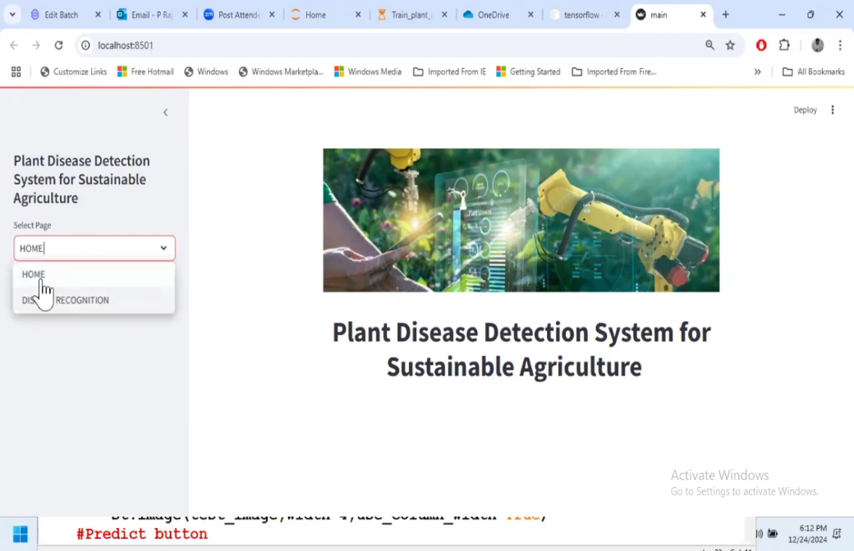

**Figure 2: Home Page**

**7**

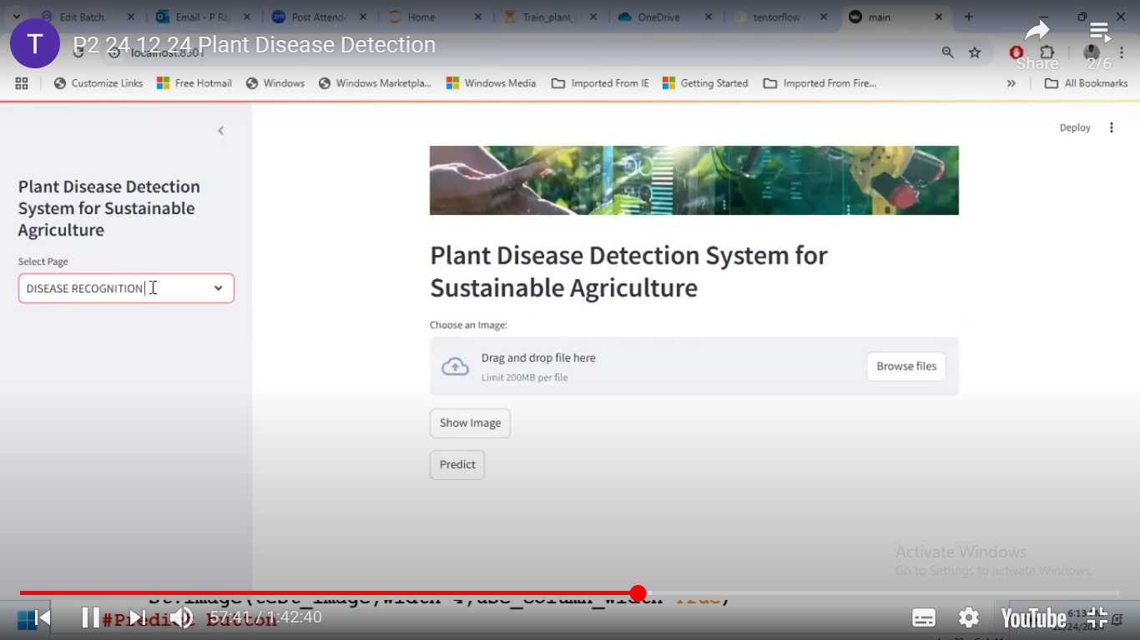

**Figure 3: Disease Recognition Page**

* On the disease recognition page, users can upload images for prediction from the test folder.

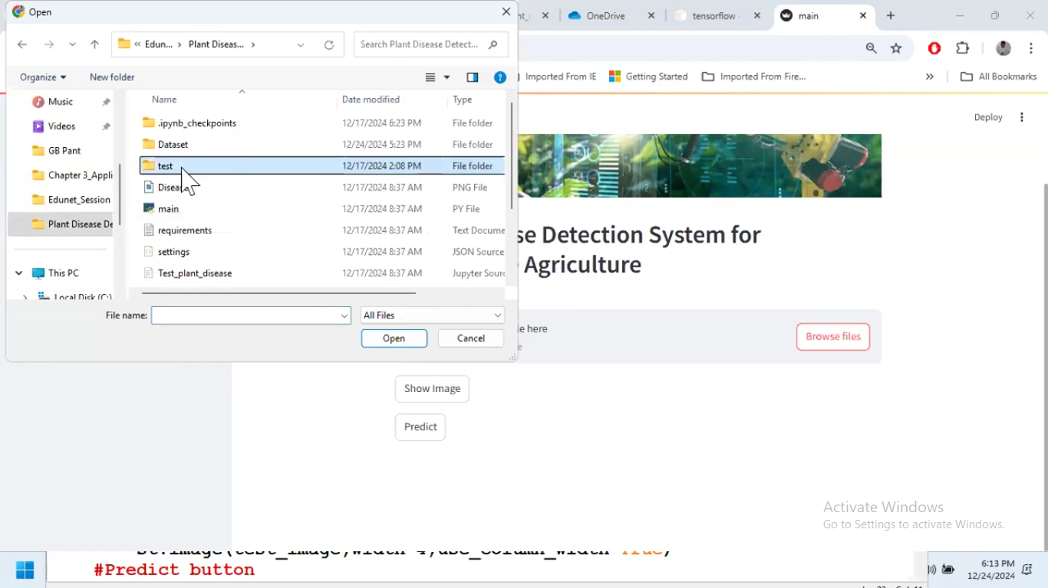

**Figure 4: Browsing Files for Prediction**

**8**

* The results include disease name and recommended actions.

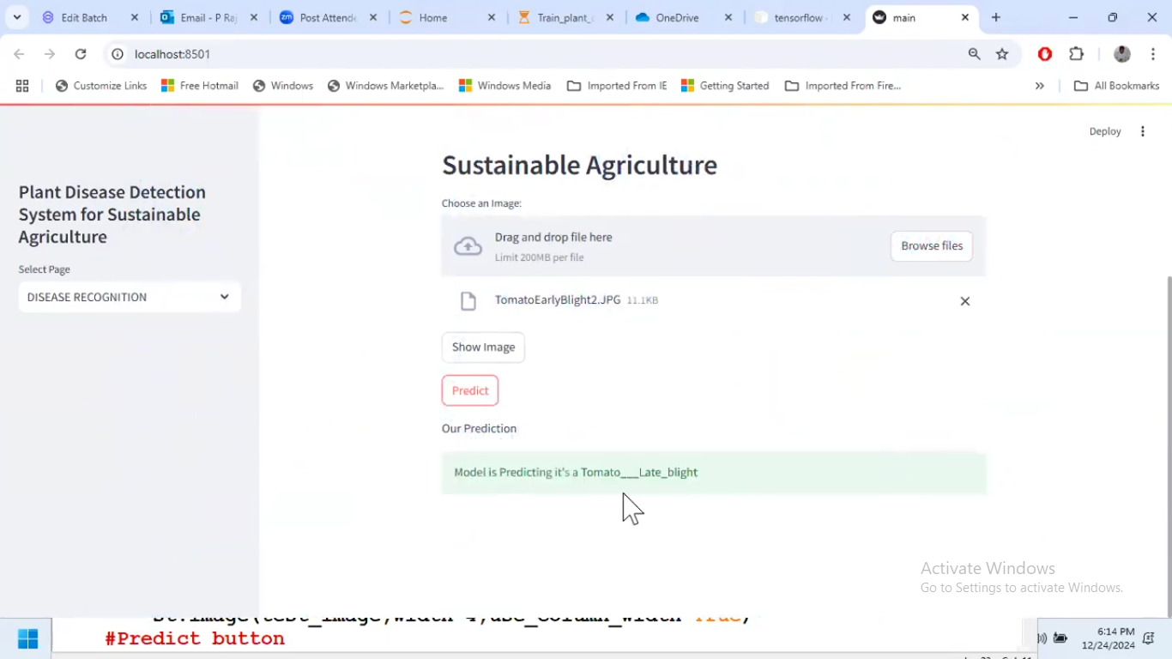

**Figure 5: Disease Prediction**

**4.1.5 Deployment:**

The application was tested locally using Anaconda and Jupyter Notebook.

**4.2 Result:**

The model achieved an accuracy of 93% on the test dataset, demonstrating its ability to effectively classify plant diseases. Sample predictions on unseen images showed accurate detection of common diseases such as:

* Early Blight in potatoes
* Yellow Curl in tomatoes
* Rust in apple cedar

Overall, the system's performance was validated against indicating its reliability in real-world applications.

* 1. **GitHub Link for Code:**

https://github.com/Aleeza786/Plant-Disease-Detection-System-for-Sustainable-Agriculture.git

**9**

**CHAPTER 5**

**Discussion and Conclusion**

**5.1 Future Work:**

**5.1.1 Expand the Dataset:**

* Include diverse images from multiple sources to better capture variations in plant diseases across different regions and climates. This will improve the model's robustness and applicability to real-world agricultural conditions.
* Collect real-time images from farms and agricultural fields to complement publicly available datasets like Plant Village.

**5.1.2. Enhance Model Performance:**

* Experiment with advanced architectures like Vision Transformers (ViT) or EfficientNet for potentially better classification accuracy and efficiency.
* Incorporate transfer learning techniques to leverage pretrained models on large-scale datasets for better generalization on smaller, domain-specific datasets.

**5.1.3. Address Overfitting:**

* Implement advanced regularization techniques such as dropout, batch normalization, or early stopping to mitigate overfitting.
* Use k-fold cross-validation during training to assess the model's performance on unseen data.

**5.1.4. Optimize for Resource Constraints:**

* Develop lightweight models or use model quantization techniques to reduce computational requirements, enabling deployment on edge devices like smartphones or IoT-enabled devices in farms.
* Use frameworks like TensorFlow Lite or ONNX for efficient inference on mobile and embedded systems.

**5.1.5. Improve User Accessibility:**

* Develop a mobile application that integrates the model for easy use in remote areas where internet access may be limited.
* Incorporate multilingual support in the user interface to cater to farmers from different linguistic backgrounds.

**5.1.6. Real-Time Monitoring:**

* Explore the integration of IoT devices equipped with cameras to capture plant images continuously, providing real-time disease detection and alerts.
* Use drones or automated imaging systems to monitor large-scale fields.

**10**

**5.1.7. Incorporate Explainability:**

* Implement explainable AI techniques to provide insights into the model's predictions, helping farmers understand why a specific disease is detected.
* Highlight affected areas in the input images using heatmaps or Grad-CAM visualizations.

**5.1.8. Broaden the Scope:**

* Extend the model to cover a wider range of crops and diseases, including those less commonly studied.
* Develop functionality to assess plant health beyond diseases, such as nutrient deficiencies or pest damage.

**5.1.9. Collaborate with Agricultural Experts:**

* Engage with agronomists and plant pathologists to validate predictions and refine the system further.
* Partner with agricultural organizations to facilitate large-scale testing and adoption of the system.

These enhancements and expansions will make the system more effective, accessible, and impactful, contributing to sustainable agricultural practices on a broader scale.

**5.2 Conclusion:**

This project contributes significantly to the field of precision agriculture by addressing the pressing issue of plant disease detection. The development of a deep learning-based system offers a scalable and efficient approach to identifying plant diseases, enabling timely intervention and reducing crop losses. The integration of an easy-to-use web application ensures accessibility for farmers, bridging the technological gap and empowering them with actionable insights.

By minimizing the indiscriminate use of pesticides, the system promotes environmentally sustainable practices, reducing the negative impact on biodiversity and human health. Moreover, the project sets a foundation for future advancements in agricultural technology by exploring scalable solutions, mobile integrations, and real-time monitoring systems. Overall, this project highlights the potential of artificial intelligence in revolutionizing traditional farming practices and contributing to global food security and environmental conservation.

**11**

**REFERENCES**

[1] Gaurav Verma, Charu Taluja, Abhishek Kumar Saxena “Vision Based Detection and Classification of Disease on Rice Crops Using Convolutional Neural Network” ,2019.

[2] Nikhil Shah1, Sarika Jain2 “Detection of Disease in Cotton Leaf using Artificial Neural Network”,2019.

[3] Ch. Usha Kumari “Leaf Disease Detection: Feature Extraction with K-means clustering and Classification with ANN”,2019.

**12**